**Steps to perform:**

1. Create an S3 bucket with a unique name and upload the CSV file to the S3 bucket (ensure that the file is in UTF-8 format only)

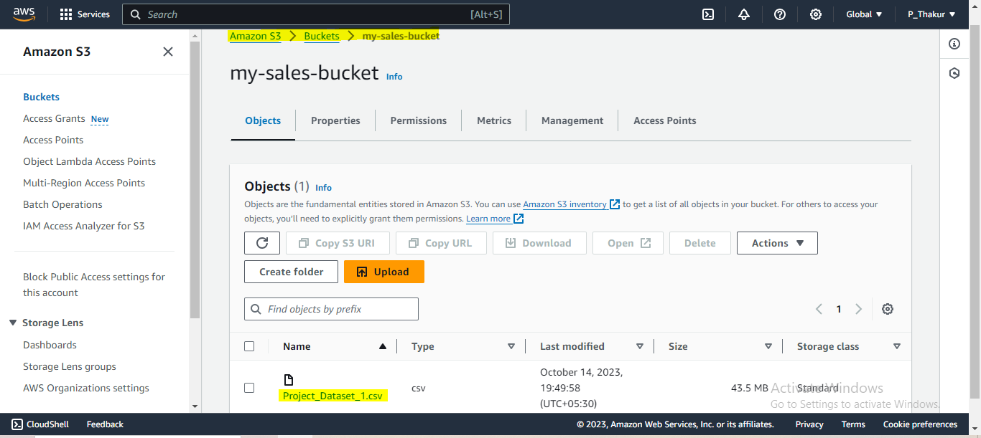

1. Create a crawler to crawl the CSV data and generate a metadata catalog

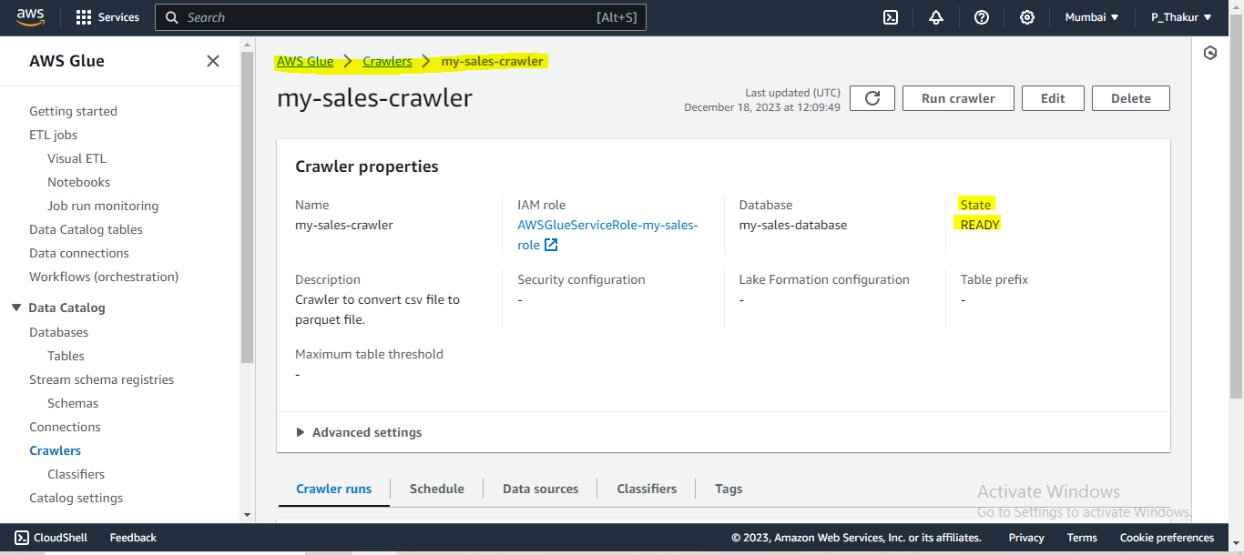

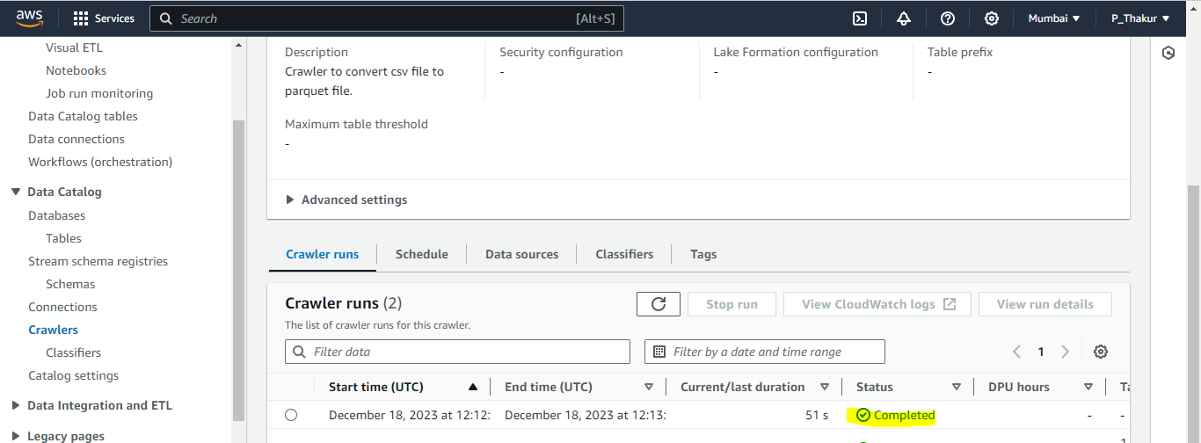

1. Create a Glue job to transform the data into the Parquet format as CSV is not optimal for data warehouse queries

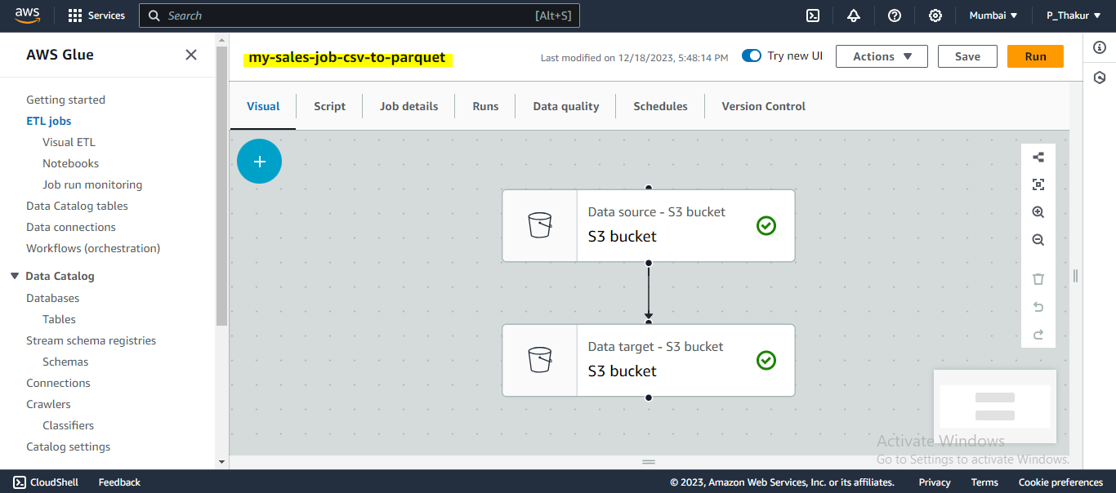

**Source Bucket:-**

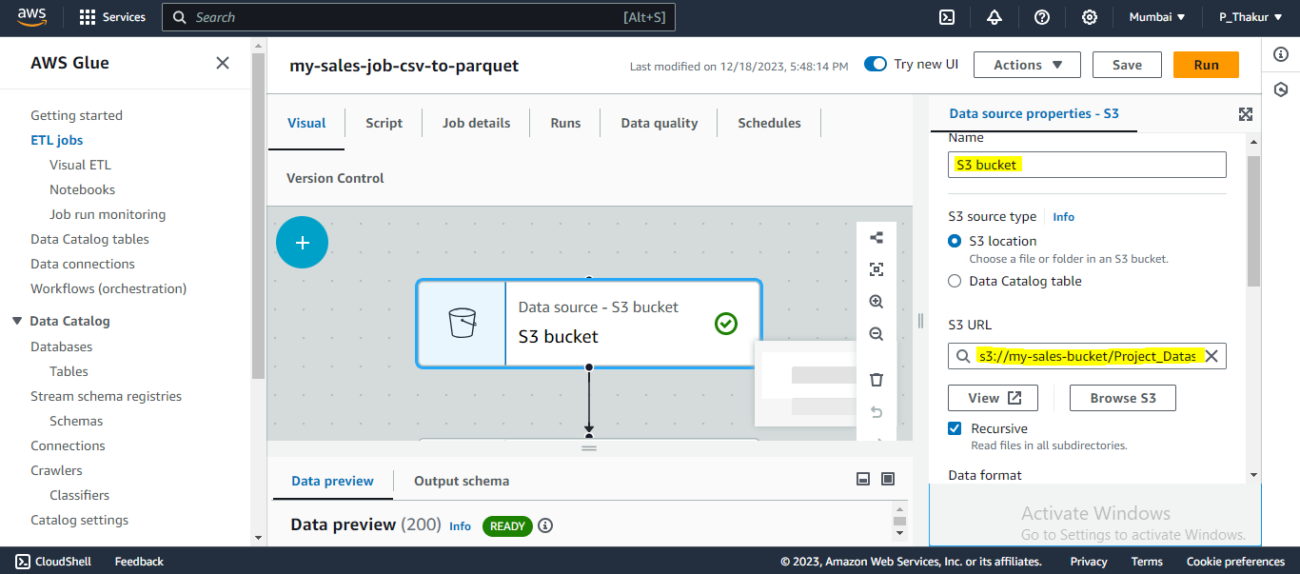

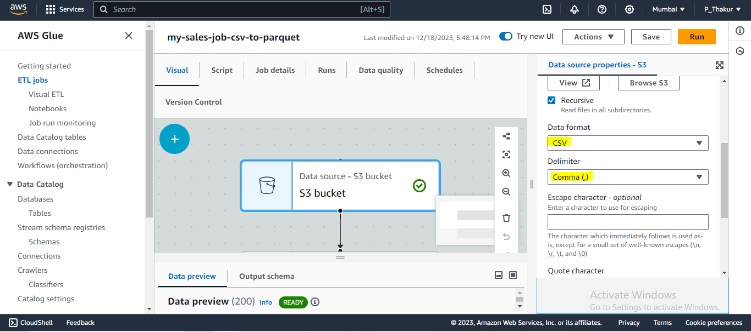

**Target Bucket :-**

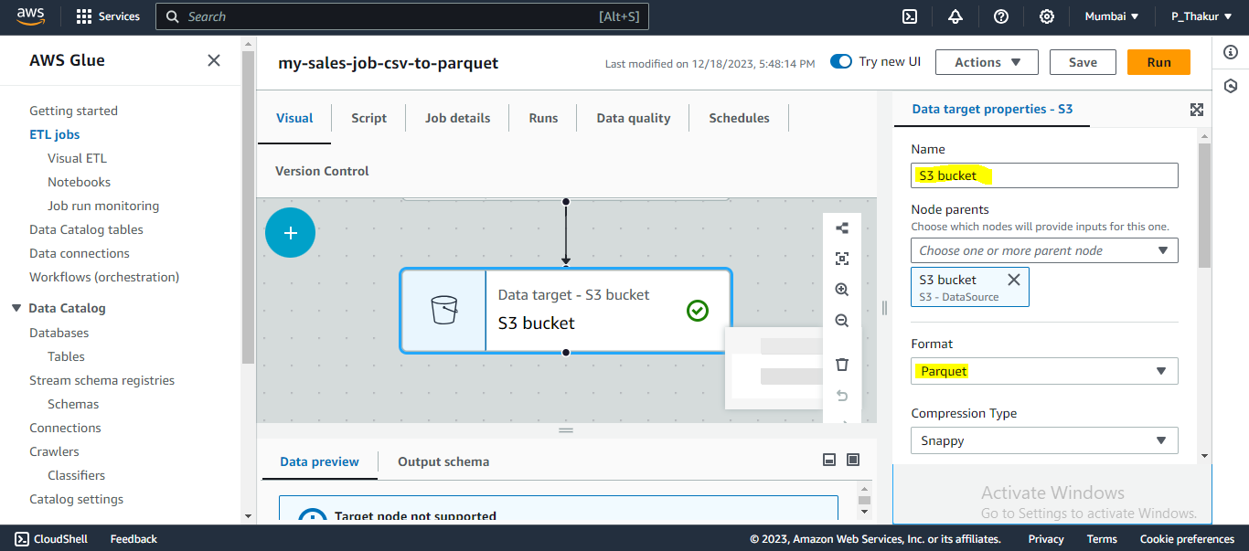

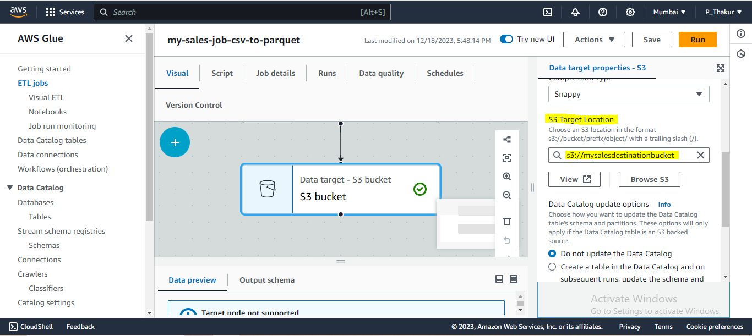

1. Add another crawler to crawl the Parquet data files to generate the metadata catalogue of the Parquet file in order to query it with Athena

